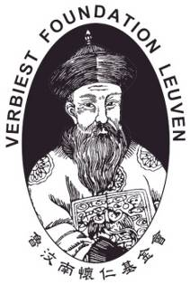
Verbiest Update
Information on the activities of
Verbiest Institute KULeuven, Verbiest Institute Taipei
And Chinese College Leuven
sent by e-mail, occasionally by Verbiest Foundation to its friends

Nr 16 – March – 2011

The illegal bishops ordination at Chengde (Hebei)
should not block the 40-year-old dialogue policy of Rome

Pope Paul VI and Cardinal Agostino Casaroli started the dialogue with China in 1970
In 1964 Pope Paul VI wrote the encyclical “Ecclesiam Suam” (”His Church”) promulgating one central message of Vatican II namely: the Catholic Church wishes to dialogue with all religions and all different ideologies in the world. This was a 180 degree U-turn from the encyclical “Divini Redemptoris” (Divine Savior”) in which Pope Pius XI – in 1937, during the reign of Stalin – attacked Communism in very aggressive language calling it ‘diabolic’.

In 1970 Pope Paul VI took the first concrete steps towards dialogue with China, strongly supported in this by Cardinal Agostino Casaroli, his Secretary of State and promoter of dialogue between Rome and the Communist governments in Eastern Europe. In Rome Pope Paul VI visited the World Food and Agricultural Organization (FAO). In his speech he observed that one of the biggest countries in the world was not yet a member of FAO. It was a historical and generous gesture towards China that the Pope publicly pleaded in favor of China’s membership in a UN organization at a time when the Cultural Revolution was still going on in China and well before President Nixon visited China. In 1971, when China entered the UN, the Vatican transferred the Nuncio of Taiwan to Bangladesh, leaving in Taiwan only a Chargé d’Affaires (until today).

During 25 years Pope J-Paul II faithfully followed that line of dialogue with China. He faced many critical events, traps which tried to trick the Church into confrontation. When China illegally ordained 5 bishops on Epiphany 2000, the Pope reacted rather low-key because he knew very well that not “China” but only “some conservative communists in China” were responsible. On October 1, 2000 the Pope ordained 120 Chinese martyrs and China reacted by launching a campaign insulting and humiliating all canonized foreign missionary saints in dozens of articles published in the Chinese media using the language of the Cultural Revolution. Pope John Paul II once again avoided confrontation. When China requested an apology, he did apologize but not for the canonization as requested by China. The Pope apologized, in terms carefully selected by himself: for events of the 19th century in which the Church was indirectly involved and which could have possibly caused pain to Chinese people. Even the great imperialistic powers -- the real culprits of the Opium War – have never offered such an apology to China. Many of us have forgotten these historical gestures of Pope Paul VI and Pope J-Paul II. Not everybody in the Church agreed with their policies at their time, yet their wisdom kept the road of dialogue with China open. It teaches us lessons also today.

Popes and presidents of countries decide policies today with foresight for the far future
When Cardinal Casaroli promoted his policy of dialogue with Eastern Europe many of those who remembered the dramatic suffering of Catholics in these Communist countries disagreed because they sympathized with Cardinal Mindzenty who had been found guilty of treason by a “People;s Court” in Communist Hungary in 1949. The Holy See also respected the merits of Cardinal Mindzenty and of those who suffered with him, yet by 1970 the time had come to open roads of dialogue. Today we thank God for the foresight and courage of prophets like Pope Paul VI and Cardinal Casaroli whose foresight paved the way.

In 1999 Party General Secretary Jiang Zemin returned to Beijing after his visit to Europe. He decided to normalize Sino-Vatican relations. But he met with shrewd opposition of those in his own Communist Party who were not ready for it. They were the ones who organized the 5 illegal Bishops ordinations on Epiphany 2000 sabotaging the whole plan of Jiang Zemin. Pope John Paul II clearly understood what happened. He avoided the trap, reacted low-key and, although dialogue was postponed, the road for dialogue was kept open.

History has repeated itself in the illegal ordination of Chengde
All through 2010 a positive dialogue went on for months producing positive results for China as well as for Rome: ten bishops were ordained with the agreement of both sides. The world looked on approvingly and understood this as a positive response of the Chinese government to the call for dialogue of Pope Benedict XVI. But apparently some Chinese government circles – perhaps of a higher level? -- disagreed. They organized the illegal ordination in Chengde by calling the police forcing the bishops to do the ordination and offending thereby some important Church laws. Conservative communists succeeded once again in sabotaging Sino-Vatican dialogue luring the Holy See into punishing the bishops and cutting off the dialogue with China. But Rome has learned from the past.

Some Catholics outside China were quicker than Rome to condemn the Chinese bishops. They prayed and did penance for the mistakes committed by the bishops in China; but the Holy See did not judge. Past experiences under Pope J-Paul II have taught Rome many lessons about the complex situation inside China. The Holy See wisely decided to investigate first the wider pastoral situation of the Church before deciding whether punishments defined in Canon Law will be applied. The possibility that punishments will be applied remains open of course. Rome has the obligation to see to it that Church Law is respected by the “official” as well as by the “unofficial” communities. There are indeed indications that in both these communities some Church leaders – not all – show a lack of respect for Church Law. They make it difficult for the Holy See to offer a well-balanced response to their situation. All this shows how difficult it will be for Rome to handle correctly this critical and delicate situation with the foresight and the wisdom of John Paul II who wisely avoided the trap put in front of him by the incident of Epiphany 2000. The Chengde incident is a similar trap for Pope Benedict XVI.

Before judging one must understand the situation from inside China
Bishops in China are worried. They are aware that they were forced (tricked) into offending important regulations of Church Law. They know that Rome investigates and wonder what the final decision will be. Rome faces a delicate, historical decision. Bishops – those of the “official” as well as of the “unofficial” communities -- have the obligation to keep clearly in mind their own status as Catholic bishops, members of the College of Bishops united with the Pope. Their own faithful want them to respect this investigation and avoid to worsen the situation by openly defying regulations of Church Law in what they say and do; that would not only offend Rome, it would even disappoint their own Catholics who have been very understanding for them so far.

At the same time Chinese bishops call the attention of Rome to some important decisions taken at the “badahui” (the 8th Congress of Catholic Delegates) and which are in fact important evolutions in the Church in China. First: the newly approved statutes of the Bishops Conference now state, for the first time in history that for matters of faith and morals Chinese bishops must follow the directives of “the successor of Peter”. The expression “successor of Peter” has in the past never been used in any official text in China. Secondly: after the “badahui” civil authorities formally announced in Beijing that in the future the one in charge of deciding matters of the Church in China is the chairman of the “Bishops Conference”. No more the “Patriotic Association” as was the case during 50 years! That is an historical change! It is the first time ever that the “chairman of the Bishops Conference in China” receives such authority. From now on it will be the bishops who direct the Church in China. This is good news for so many dioceses which have been without a bishop during many years and which urgently need help. The change allows bishops to set up commissions for liturgy, pastoral, social work etc through which much cooperation between dioceses can be promoted etc. During their first meeting in Kunming in the week of February 21-25 the bishops became aware that, even while the present chairman and the “Bishops Conference” itself are not yet legal, these recent decisions create a new situation and open new possibilities of growth for the Church. In spite of many offenses against Church Law a new phase of Church building in China is starting.

It is precisely the task and challenge of Rome and the Universal Church – as part of the ‘evaluation process during the post-Chengde situation – to enter into close, personal contact with the bishops in China in order to understand their interpretation of the situation. How do they see what happened in Chengde? How do they see the future? What do they propose? It is but normal that Chinese bishops will offer full, objective information to the Holy See. Misunderstandings have often risen because of insufficient information. To remedy this both sides must take positive steps. Before answering the questions on whether somebody should be punished, who should be punished and how, Rome will, hopefully, try to enter into personal contact with the bishops and listen to them. We know the obstacles in China that block such contacts but it is crucial – and entirely in line with applying the spirit of the letter of Pope Benedict XVI – that Rome does everything possible to achieve this kind of personal contact with all bishops in China, without exception. The task of the bishops is to build up the Church in China in difficult circumstances; the difficult challenge of the Universal Church is to use all means possible to realize an open communication with the bishops, priests and faithful in China: in charity, realistic and frankly. That is the spirit of the gospel as it is so well expressed in the letter of Pope Benedict XVI. There are many indications that we have not achieved yet this level of dialogue inside the Church.

In spite of their worries the Chinese bishops are much aware of this chance for growth that lies in their hands. They are even enthused about it. Every time we visit China we share their enthusiasm which clearly manifests itself in their care for the Adult Catechumenate and their plans to organize formation sessions for priests, religious and lay catechists. The bishops are aware that to respond to the many opportunities for evangelization in China and to the challenges of their situation they themselves, together with their priests and faithful need to engage in ongoing formation, studying various official documents published by the Holy See.

One “huizhang” (lay leader) of an unofficial (“underground”) Catholic village told me recently in China: “Father, in the past the main enemy of the Catholic Church in China was the Communist Party. Today we Catholics are our own biggest enemy! Pope Benedict XVI wrote such a wonderful letter calling for unity and reconciliation; but we do not study or follow it sufficiently! Even some priests prevent us from doing so!”. His words impressed me. He was right. Not even the events of Chengde and the “Badahui” should block our efforts to follow the line drawn by Pope Benedict XVI: seek unity, through dialogue and reconciliation. Avoid to be drawn into the “struggle” promoted by politicians who try to divide the Church. We avoid therefore to speak in terms of ‘hard-liners’ or ‘soft-liners’. In our prayer we only seek the line of the Gospel, the line of unity in charity, the only one that counts for us Christians.

Jeroom Heyndrickx cicm

Know and support the China Programs of Verbiest Foundation

- The Ferdinand Verbiest Foundation is named after the Belgian Jesuit missionary Ferdinand Verbiest who was a famous astronomer and teacher of Emperor Kangxi in the 18th century. The Foundation was established by CICM missionaries in 1982 at the Leuven University (Belgium).

- Verbiest Foundation is chaired by Cardinal Godfried Danneels of Malines (Belgium). Members represent the missionary congregations: CICM, OFM, Brothers of Charity. The Foundation sponsors the activities of Verbiest Institute at Louvain University (Belgium) and of the Verbiest Institute in Taipei (Central Building, 8th floor). Since May 1, 2009 the Foundation also sponsors the Chinese College Leuven. Through these institutes it promotes academic research on the history of the Chinese Catholic Church and pastoral cooperation with the Church in China.

- The priority concern of Verbiest Foundation is: to develop a new relationship with the Church in China. In line with the letter of Pope Benedict XVI it promotes reconciliation and unity inside the Catholic Church without prejudice for or against anyone of the two Church communities in China.

- The most efficient way to help the Church in China is to invest in the formation of Church personnel. Therefore the Foundation offers support for the formation of ministers (priests, religious, lay catechists) for the Catholic Church in China. The foundation offers scholarships for the formation of priests, religious and also lay ministers. Priority goes to supporting formation programs inside China. We invite also priests and religious to come abroad for obtaining a more specialized formation in the field of evangelization in institutes in Europe, the USA or the Philippines. Scholars are expected to return to China and teach in Catholic seminaries and formation institutes. We are in direct contact with the dioceses or religious communities in China and we see to it that the money of donations is well used.

- The Foundation also responds positively to requests from China to support (small scale) development projects in dioceses of N-W China: Gansu, Qinghai, Inner Mongolia, Ningxia.

- Paul Braeckmans represents Verbiest Foundation in the USA. His contact address is at St. Thomas Aquinas Parish, L.A., in cooperation with Fr. Lui, pastor of the parish. Tel: (626) 282-8017; Fax: (323) 264-2524 – E-mail: paulbraeckmans@yahoo.com

- Contributions are tax-deductable if written out to: Chinese Mission Fund, St. Thomas Aquinas Church, 1501 South Atlantic Boulevard, Monterey Park, CA 91754, USA

Website of Verbiest Institute：
http://www.kuleuven.be/verbiest/

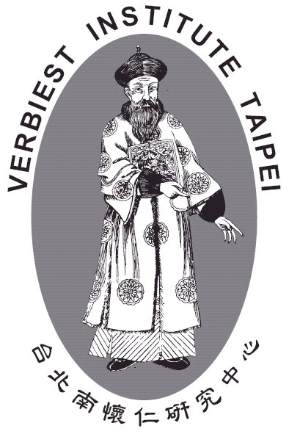
Contacts

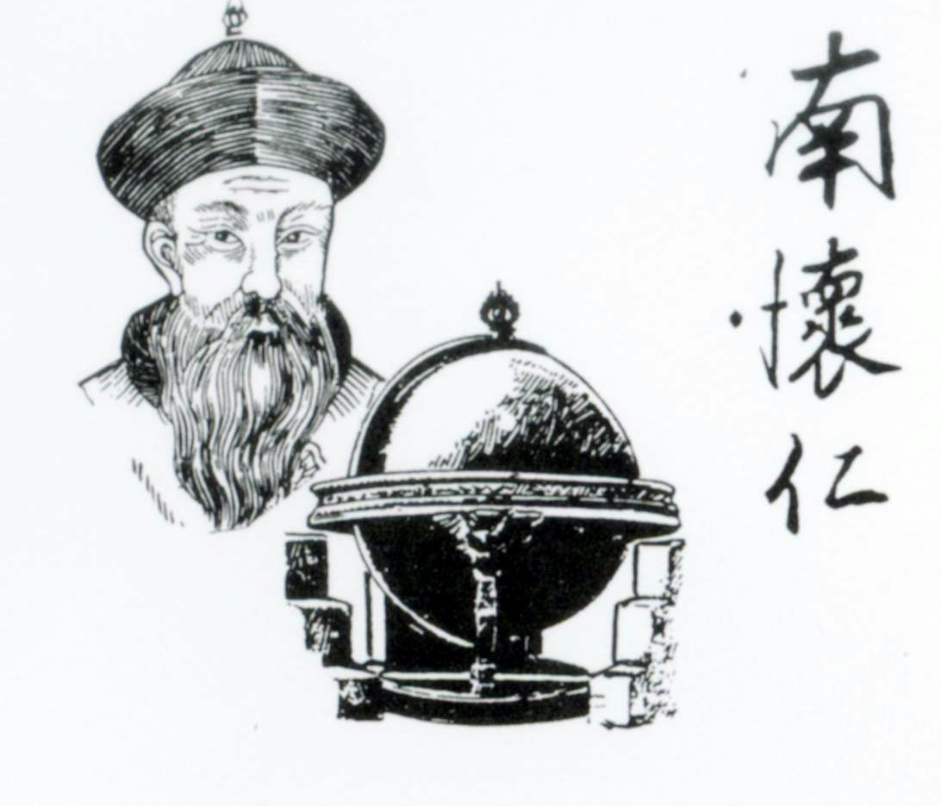
V.I.-KULeuven
Tel: +32-16-324350
Fax: +32-16-324455
E-mail: Verbiest.Inst@fvi.kuleuven.be

V.I.-Taipei
Tel: +886-2-23149631
Fax: +886-2-23119794
E-mail: vftaipei@seed.net.tw

